WANDERWAY TOUR & TRAVEL DATA ENGINE

A PROJECT REPORT

Submitted To
Mr. Navdeep Singh Sodhi

Submitted By
SUKHLEEN KAUR
25MCA20031
25MCA6 (B)

in partial fulfillment for the award of the degree of

MASTERS OF COMPUTER APPLICATIONS

IN

UNIVERSITY INSTITUTE OF COMPUTING

CHANDIGARH UNIVERSITY



Aug-Nov, 2026

ACKNOWLEDGEMENT
I would like to express my sincere gratitude and deep sense of appreciation to Chandigarh University and the University Institute of Computing (UIC) for providing me with the opportunity and facilities to work on this Business Analytics mini project, titled "WanderWay Tour & Travel Data Engine".
I am profoundly indebted to my project supervisor and mentor, Mr. Navdeep Singh Sodhi, Assistant Professor, Department of Computer Applications, for his invaluable guidance, continuous encouragement, and constructive feedback throughout the development of this project. His expertise in database management systems and analytics was instrumental in shaping the architecture and analytical queries executed in this project.
Sukhleen Kaur

1. ABSTRACT
The WanderWay Tour & Travel Analytics System is a relational database-driven business analytics project developed using MySQL as the primary data store and analytical engine, integrated with a lightweight Flask web interface for data ingestion and dashboard reporting. Designed to demonstrate practical database modeling and business intelligence execution, this project transforms raw reservation data into structured operational metrics. By architecting normalized database tables (`users`, `customers`, `destinations`, `tour_packages`, `bookings`, `payments`), the system facilitates aggregate SQL reporting, customer booking frequency analysis, revenue calculation by package/destination, and live transactional monitoring. This project fulfills the core requirement for a database-focused Business Analytics mini project.

2. INTRODUCTION
In modern business analytics, relational databases serve as the foundational backbone for operational decision-making. In the travel and tourism industry, capturing structured data regarding customer demographics, destination popularity, package revenue performance, and payment statuses is vital for optimizing sales strategies and resource allocation.
This mini project focuses on **MySQL Data Engineering and Relational Analytics**. The backend models tourist transactional lifecycles, executing complex relational SQL joins (`JOIN`, `LEFT JOIN`, `COUNT`, `SUM`, `ORDER BY`, `GROUP BY`) to power executive analytical dashboards. The web interface acts as a dynamic frontend layer to showcase real-time SQL execution and data collection.

3. OBJECTIVES
Relational Data Modeling: Design an optimized relational schema in MySQL supporting normalized storage across customers, destinations, packages, bookings, and payments.
SQL Analytics Execution: Develop parameterized SQL queries to extract key business indicators (KPIs) such as Total Users, Total Bookings, Revenue distribution, and Active Tour Catalogs.
Data Integrity & Transaction Control: Enforce ACID properties in MySQL using relational foreign key constraints and transactional rollback mechanisms (`conn.commit()`, `conn.rollback()`).
Analytical Dashboarding: Render real-time database aggregations to administrative business viewers to track revenue and booking throughput.

4. SOFTWARE & ENVIRONMENT REQUIREMENTS

4.1 Software Requirements
Database Management System: MySQL Server 8.0 / MariaDB (Primary SQL Engine for storing data schemas, tables, index definitions, and executing query optimization).
Database Client & Connector: `mysql-connector-python` for connecting Python scripts to the MySQL database engine via dictionary cursors.
Programming & Analytics Framework: Python 3.9+ with Flask framework used as a data collection web client and dashboard renderer.
Query Development Environment: MySQL Workbench / Command Line Client for DDL/DML script execution and schema inspection.
Frontend Reporting UI: Jinja2 Templating, HTML5, CSS3, and JavaScript for rendering SQL aggregation results into tables and KPI cards.

4.2 Hardware Requirements
Processor: Intel Core i3 / AMD Ryzen 3 or higher.
RAM: 4 GB minimum (8 GB recommended for simultaneous MySQL server daemon and Python script execution).
Storage: 500 MB available storage for database space, index storage, and application logs.

5. MYSQL DATABASE ARCHITECTURE & DATA MODELING
The project architecture centers on relational database design principles. Data entities are normalized up to Third Normal Form (3NF) to eliminate redundancy and maintain analytical consistency across transactions.

5.1 Relational Schema Definitions (Data Dictionary)
Table Name | Primary Key | Foreign Keys | Business Analytics Purpose
users | user_id | None | Stores user registrations and login credentials for user conversion analytics.
customers | customer_id | user_id | Maintains verified customer identity, contact details, and phone attributes for CRM tracking.
destinations | destination | None | Catalogs geographic tour destinations for location-wise demand analytics.
destinations | _id | None
tour_packages | package_id | destination_id | Stores tour product details, duration, and price points for revenue modeling.
bookings | booking_id | customer_id, pack age_id | Core fact table recording travel dates, party headcount, total revenue, and status tracking.
payments | payment_id | booking_id | Stores transaction methods (UPI, Card, Net Banking, Cash) for financial channel analysis.

6. SQL IMPLEMENTATION & ANALYTICAL QUERIES
The core analytical power of the WanderWay project resides in custom SQL queries written to extract real-time insights from the MySQL storage backend.

Executive Dashboard Analytics & KPI Query Extraction
-- 1. Aggregating System Metrics for Business KPIs
SELECT COUNT(*) AS total_users FROM users;
SELECT COUNT(*) AS total_bookings FROM bookings;
SELECT COUNT(*) AS total_destinations FROM destinations;
SELECT COUNT(*) AS total_packages FROM tour_packages;
-- 2. Comprehensive Relational Analytics Query for Admin Dashboard
SELECT b.booking_id, u.name AS customer_name, u.email, c.phone, p.package_name, d.name AS destination,
b.travel_date, b.persons, b.total_amount, b.status,
pay.payment_method, pay.payment_status
FROM bookings b
JOIN customers c ON b.customer_id = c.customer_id
JOIN users u ON c.user_id = u.user_id

7. BUSINESS INTELLIGENCE & DASHBOARD METRICS ANALYSIS
The analytical dashboard converts MySQL relational data into visual business indicators essential for travel agency managers:
Volume Aggregations: Live display of total platform users, active bookings, registered destinations, and active packages.
Financial Channel Breakdown: Tracking payment methods (UPI, Card, Net Banking, Cash) to analyze customer payment channel preferences.
Demand Tracking: SQL `JOIN` outputs allow business managers to identify top-performing travel destinations and tour packages.

8. OUTPUT SCREENS & ANALYTICAL PROOFS
Signup Page | Login Page
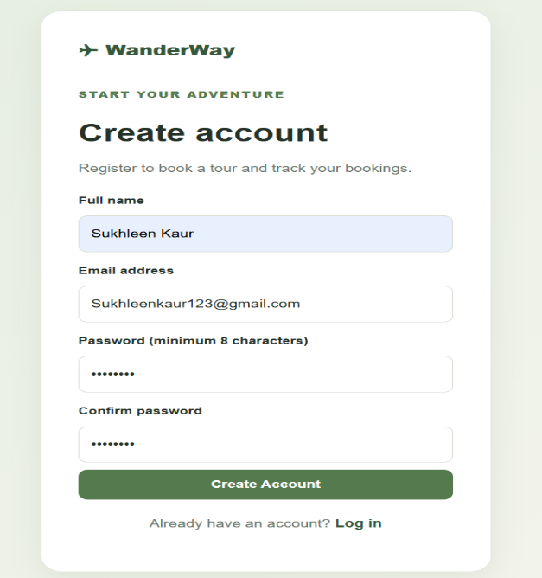 | 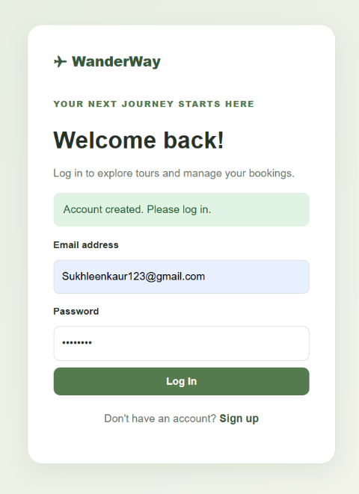
Home Page | Destination Page
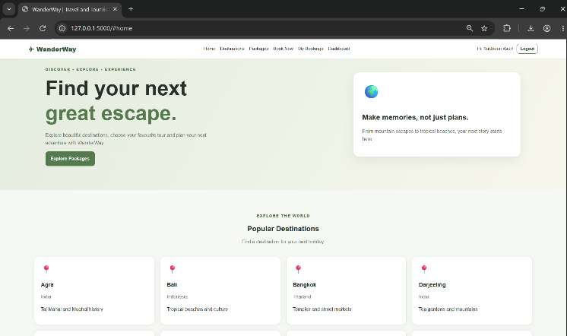 | 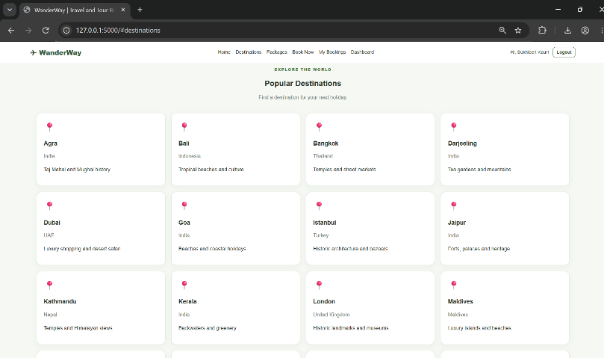
Booking Page


Dashboard Page
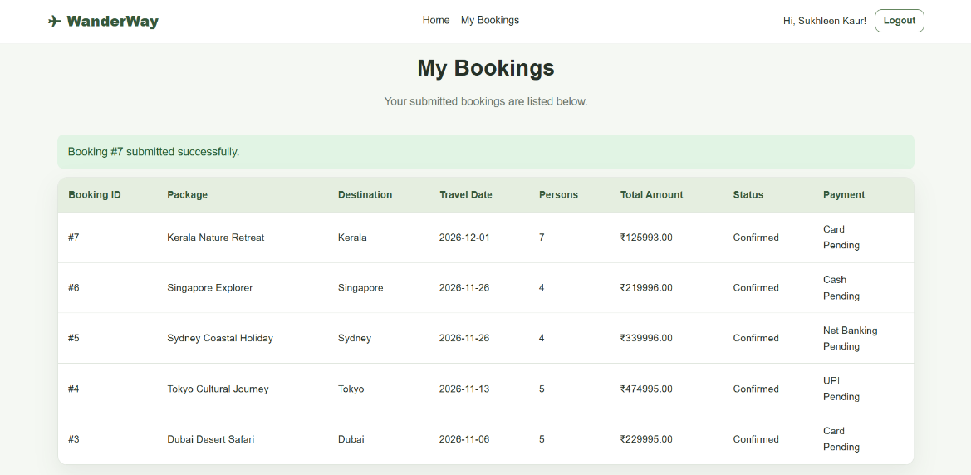

9. CONCLUSION
The WanderWay Tour & Travel Analytics System successfully demonstrates the practical application of MySQL relational database management and SQL analytics within a real-world business context. The project fulfills all requirements specified for a Business Analytics mini project by establishing structured schemas, maintaining data normalization, writing analytical multi-table queries (`JOIN` operations), and presenting decision-support analytics on an executive dashboard.
By leveraging MySQL alongside Python Flask, the project showcases end-to-end data pipelines: capturing user actions, storing normalized records, enforcing transaction rollback safeguards, and querying aggregate insights for organizational business intelligence.

